https://indiglobalexpo.com/exhibition-layout

- Exhibition Layout replace with Event Layout
- Add Logo
- Remove Download Option
- Change big centre image I have send you.
- Direct Access - Easy accessibility from Suvarnabhumi International Airport.
- On-site Stay - Luxury rooms available at the venue for exhibitors and VIPs at contracted rates.

https://indiglobalexpo.com/teams
- About The Organizer replace with About the Organizing Partner.
- Brand Vista Consulting Solutions remove solutions word.
- Change below 3 images.
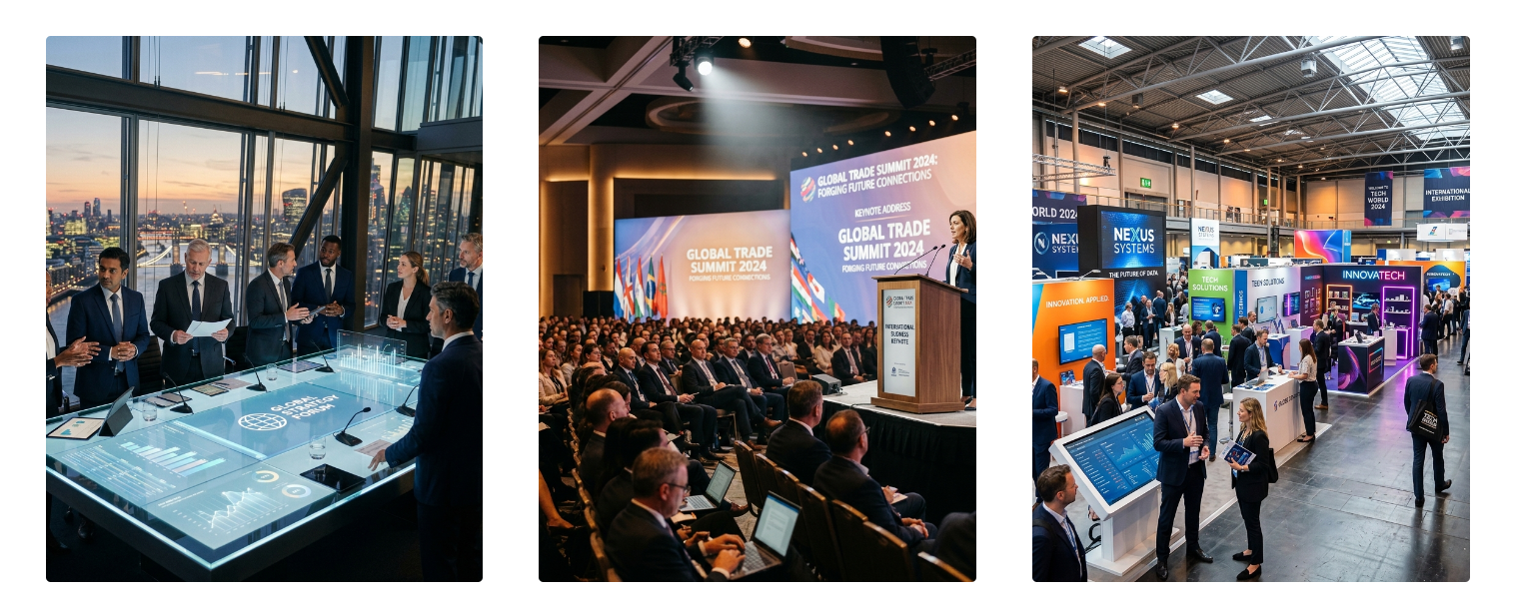

- Add Brand Vista Consulting login in right site with white background.


